Run the project and execute below URL

<http://localhost:1558/allEmployees.aspx>

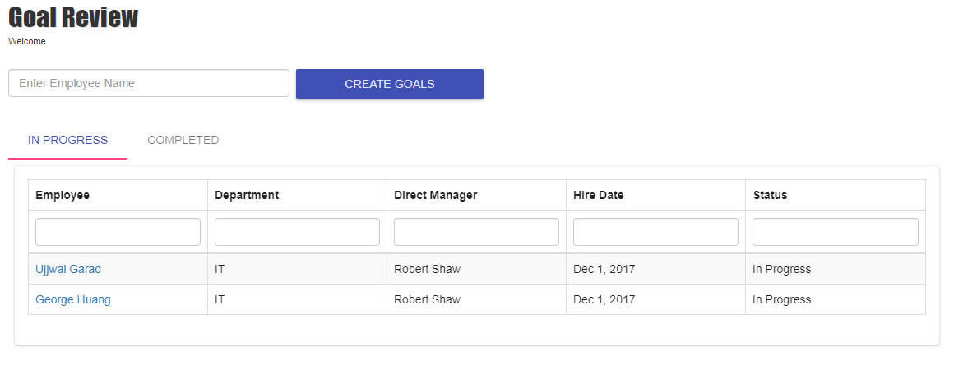

Based on your role (HR or Manager) you can manage the goals and feedback for employee.

